ASSIGNMENT -1 (KASHISH) (SQL/PL)
Q-1 Install MySQL Workbench on your computer, connect to the local MySQL server, and take a screenshot of the default databases shown in the Schemas panel?
Ans).
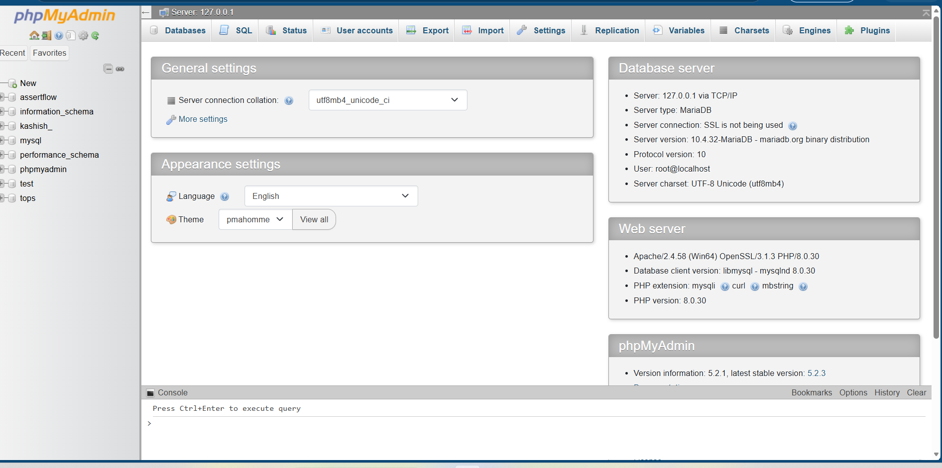

Q-2 Create a new database called InstaClone in MySQL Workbench, then create a table named Users with columns: user_id (INT, primary key), username (VARCHAR), email (VARCHAR), and followers_count (INT)?
Ans).
CREATE DATABASE InstaClone;
USE InstaClone;
CREATE TABLE Users (
user_id INT PRIMARY KEY,
username VARCHAR(50),
email VARCHAR(100),
followers_count INT
);
SHOW TABLES;
DESCRIBE Users;
Q.3) Insert 3 sample users into the Users table you created, using realistic Instagram-style usernames and follower counts?
Ans).
USE InstaClone;
INSERT INTO Users (user_id, username, email, followers_count)
VALUES
(1, 'travelwithriya', 'riya@gmail.com', 1250),
(2, 'foodie_rahul', 'rahul@gmail.com', 3480),
(3, 'techguru_amit', 'amit@gmail.com', 8950);

Verify the Data
Run the following command to display all records:
SELECT * FROM Users;

Expected Output:
User_id | Username | email | Followers_count
1 | travelwithriya | riya@gmail.com | 1250
2 | foodie_rahul | rahul@gmail.com | 3480
3 | Techguru_amit | amit@gmail.com | 8950

Q.4) Create another table in the InstaClone database called Posts with columns: post_id (INT, primary key), user_id (INT), caption (VARCHAR), and post_date (DATE). Add a foreign key from Posts.user_id to Users.user_id to establish a relationship?
Ans).
USE InstaClone;
CREATE TABLE Posts (
post_id INT PRIMARY KEY,
user_id INT,
caption VARCHAR(255),
post_date DATE,
FOREIGN KEY (user_id) REFERENCES Users(user_id)
);
SHOW TABLES;
DESCRIBE Posts;
Table Structure:
Column | Data Type | Constraint
post_id | INT | PRIMARY KEY
user_id | INT | FOREIGN KEY -> Users(user_id)
Caption | VARCHAR(255)
post_date | DATE

Q.5) Write a short comparison (3-4 lines each) of MySQL, PostgreSQL, Oracle, and SQLite, focusing on where each one is commonly used (for example: web apps, mobile apps, enterprise systems, etc.)?
Ans). Comparison of MySQL, PostgreSQL, Oracle, and SQLite
1. MySQL
- MySQL is one of the most popular relational database management systems.
- It is widely used for web applications, blogs, and e-commerce websites.
- It is fast, easy to use, and works well with PHP, making it a common choice for web development.
2. PostgreSQL
- PostgreSQL is an advanced, open-source relational database known for its reliability and powerful features.
- It is commonly used in large web applications, financial systems, GIS applications, and data analytics.
- It is ideal for applications that require complex queries and high data integrity.
3. Oracle Database
- Oracle is a commercial database management system designed for large enterprise applications.
- It is widely used by banks, government organizations, healthcare institutions, and multinational companies.
- It offers high security, scalability, and performance for managing large volumes of data.
4. SQLite
- SQLite is a lightweight, serverless database that stores data in a single file.
- It is commonly used in mobile applications, desktop software, embedded systems, and web browsers.
- It is easy to set up and is ideal for small applications that do not require a dedicated database server.

